25.18: Assuming linear variation of the resistivity with temperature:
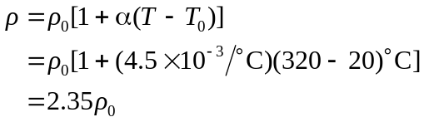
Since 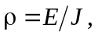 the electric field required to maintain a given current density is proportional to the resistivity. Thus

